The Impacts of Various Sorts of Weight control plans on Large People Determined to have Type 2 Diabetics
Faizal Ahmed¹, Pattrick Collins²
School of Pharmacy, Faculty of Science and Engineering, University of Wolverhampton, United Kingdom^{1,2.}

Abstract— The Assembled Country set out an objective to decrease destitution rates by half as a component of its millennial objectives, which was come to in 2010. Regardless of this decrease, consideration is as yet given by associations to diminish destitution further. Corpulence was likewise referenced in the UN report, anyway regardless of and the worldwide exertion, its rate is expanding exponentially with projections of a billion grown-ups being stout by 2025. Truly this has been clarified by Maslow's progression of necessities which express that the most fundamental need surprisingly is nourishment, which prompted the conviction that moderate sustenance decisions generally not as solid as others and as a rule contains nutrition classes which are known to add to the weight. Weight can prompt diabetes which is likely preventable. This efficient audit point was to examine the impact of nutritional categories, for example, starch, protein, and fat in various kind of eating regimens contrasted with the Mediterranean eating routine, to figure out which diet gave the best advantage to diminishing fasting glucose, weight record, abdomen perimeter, low thickness cholesterol, systolic circulatory strain levels just as expanding high thickness cholesterol levels. This audit presumed that low sugar diet gave the best advantages contrasted with high protein, high fat and Mediterranean eating regimen. A ketogenic diet was not as successful as a standard low starch diet because of a danger of parchedness. In view of these discoveries, this survey prescribes that the best eating regimen is that contains a mix of low sugar, high protein, and high fat.
Keywords— Mediterranean Diet, High Fat Diet, High Protein Diet, Type 2 Diabetes Diet.

1. Introduction
The Assembled Countries (UN), as a feature of its millennial objectives, focused on splitting neediness rates by 2015. Truth be told, this was accomplished by 2010[1]. While worth celebrating, simultaneously the rates of heftiness expanded. The association has expressed that decreasing eating regimen related sicknesses won't be accomplished on the grounds that around 1 billion of the worldwide grown-up populace are anticipated to be hefty by 2025[2,3]. For the grown-up populace in the UK, the pervasiveness of heftiness expanded from 13% of men and 16% of ladies in 1993 to 27% for the two people in 2015[4]. Anciently, people needed to chase for nourishment or be chased and expended however much sustenance as could reasonably be expected, getting ready for the conceivable future starvation. The individuals who endure had the option to deliver posterity, making the inclination to store a lot of fat a transformative preferred position. In light of Maslow's chain of importance of necessities, sustenance is an essential prerequisite for all people [5]. The Metropolitan Disaster protection CompanyTM directed a 25-year ponder on death rates among their policyholders. They recognized that corpulence was identified with diminishing future [6]. No one ought to expend overabundance sustenance, or liquor, or quick [7]. From the 1930s onwards, therapeutic investigation into the negative impacts of heftiness expanded giving the proof base to current rules and approaches.

Corpulence expands the danger of creating type 2 diabetes mellitus (T2DM), malignant growth, cardiovascular illnesses (CVD), gallbladder ailment, osteoarthritis and ceaseless back torment [8]. The proof builds up connections with endometrial, oesophageal adenocarcinoma, colorectal, postmenopausal bosom, prostate and renal malignant growths [9]. The National Heftiness Observatory expressed: "serious weight puts people at more serious danger of misery" likewise noticing shame in connection to corpulence in ladies who feel constrained to be thin [10]. Corpulence is likewise a hazard factor for building up Alzheimer's ailment. The Alzheimer's General public states; debilitating of the fornix which interfaces the cerebrum to the hippocampus to other mind areas, influence learning and memory [11]. Heftiness is connected to T2DM is a result of an expansion of "non-esterified unsaturated fats, glycerol, hormones, cytokines, star fiery markers associated with the advancement of insulin opposition" [12].

In the UK overweight and corpulence related sick wellbeing in 2014/15, cost £6.1 billion which surpasses the financing for the police, fire administration, and legal framework consolidated [13]. The yearly expense of emergency clinic inpatient care for diabetes inconveniences is assessed at somewhere in the range of £1800 and £2500 per understanding; yearly outpatient costs somewhere in the range of £300 and £370 per persistent and the expense of drug to treat confusions of diabetes is around 3-4 times the expense of the meds to treat the condition. This is prompting a complete diabetes use of around £14 billion or £1.5 million for each hour [14]. The UK is additionally falling behind in future for diabetic patients contrasted with other created countries [15]. At present, around 90% of grown-ups determined to have T2DM are overweight or hefty [16]. Most st of this individual and societal expense is considered conceivably preventable; the most significant guidance is drug adherence and keeping up a solid eating routine. Be that as it may, contention stays with respect to what may establish a solid eating regimen.

Survey Point
The point of this deliberate survey is to look at eating regimens considered advantageous for stout T2DM.
The goal is to clarify the best eating routine for corpulent T2DM patients via looking for changed databases to recover significant examinations. When the essential examinations on n the various eating regimens were recognized, the basic consequences of the correlation were removed and thought about using RevMan5TM (Biostat, Englewood NJ), figuring the normal mean for every classification of examination.

Study determination and figuring of danger of predispositions
All the chose examinations highlighted members with a mean weight record (BMI)>30 aside from Ellsworth et al., (2016) where members were permitted to enter the investigation with BMI of 25 and over [17]. Every single chosen study had very little quantities of members with the exception of; Coles et al., al (2014), Iqbal et al., (2009), Shai et al., (2008) and Lasa et al., al (2014) each had in excess of 100 members [18,19,20,21]. The example size is significant in light of the fact that a low example size compares to a decrease in certainty level l which builds the danger of an enormous mistake of mean happening. This influences unwavering quality as it turns out to be less agent of the key populace being examined. Essential examinations were recovered from EmbaseTM and PubmedTM. Papers were barred that explored examination gestational diabetes or had no connection to the proposed essential target (the impact of eating regimen on coinciding existing stoutness and diabetes). The Boolean administrators, "Or potentially" weren't connected as "diabetes" and "corpulence" are once in a while connected in mix. Studies were fundamentally assessed and incorporated into this audit are recorded in Index 1.

The picked test spoke to the normally utilized eating regimens in diabetes patients. The primary estimation dissected was the Glycated hemoglobin (HbA 1 c). Weight record (BMI) (was picked over an adjustment in weight since it's used to sort members into stout/overweight and associates with a member's weight. Midsection periphery (WP) was used as an elective cooperation of weight reduction. Likewise, an unmistakable abatement in midsection boundary can persuade a fat member to hold fast to the endorsed intercession. Low-Low-thickness lipids (LDL) and high thickness lipids (HDL) levels and systolic circulatory strain were utilized as markers of the dimension of cardiovascular risk [22]. Table 1 demonstrates the comparators utilized in this survey to think about the chose investigations' discoveries.

*HbA1c: Glycosylated Hemoglobin, BMI: weight record, WC: Midsection Circuit, LDL: low-thickness cholesterol, HDL: high-thickness cholesterol, SBP: systolic circulatory strain The CochraneTM Handbook for Deliberate Audits of Intercessions was utilized to control the plan of this survey. The CONSORTTM check rundown was used to evaluate the examinations and investigation was directed utilizing RevMan5TM.

2. FINDINGS AND DISCUSSION

The Impact of Eating regimens on HbA 1 c dimensions
The mean distinction (Figure 2) underneath is utilized to portray the contrast between the methods revealed for the high and low starch slims down separately. For this situation, it is clear low-sugar diets decline HbA₁ clevels more than high-starch eats less carbs. The outcomme for Saslow et al., (2014) was excluded in the RevMan⁵ investigation to avert slanted outcomes [23]. The examination found that the low-starch diet had huge impact on HbA₁ c with a mean distinction of 0.6.
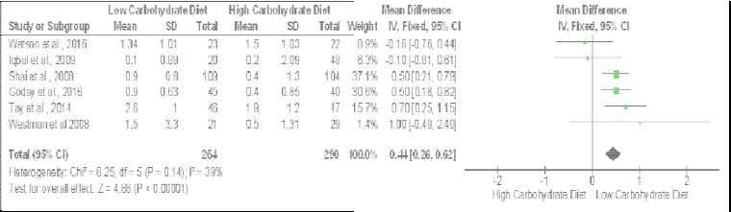

Figure 2 The effect of carbohydrate diet on HbA₁c levels (%)

The high-protein diet diminished HbA₁ c, however the impact was littler than low-starch consumes less calories (Figure 3). This is affirmed as Watson et al., (2016) investiggated sugar and protein slims down as the low-starch diet included a higher protein content [24].
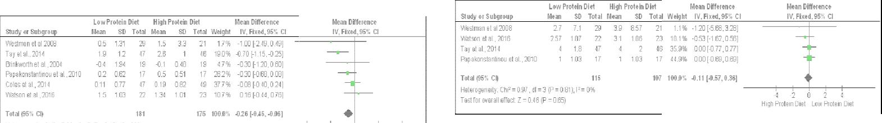

Figure 3 The effect of protein diet on HbA₁ c levels (%) Figure 7 The effect of protein diet on BMI levels (/m2)

Only two examinations explored the impact of Mediterranean eating regimens on HbA1c levels. The end is that an On-Mediterranean eating routine actuated a superior reduction in HbA1c than Mediterranean-eats less (Figure 4).
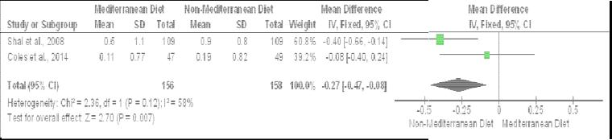

Figure 4 The effect of Mediterranean diet on H bA₁c levels (%)
The outcome for the impact of fat weight control plans on HbA1c shows that high-fat eating regimens were the least viable in a level decrease (Figure 5) compared to all others (figures 2, 3 and 4). In this investigation the Saslow et al., (2014), think about was rejected.
The impact of eating regimens on BMI
The outcomes showed that the low-starch diet likewise gave a reduction in BMI and in this manner an abatement in weight. Every one of the examinations separated from Tay et al., (201 4) and Shai et al., (2008) announced a diminishing in BMI in contrasted with the high starch diet [25,20]. Westman et al., (2008) had a low p-esteem as the SD wasn't determined and along these lines, the SD was high causing an enormous range in this computation (Figure 6).
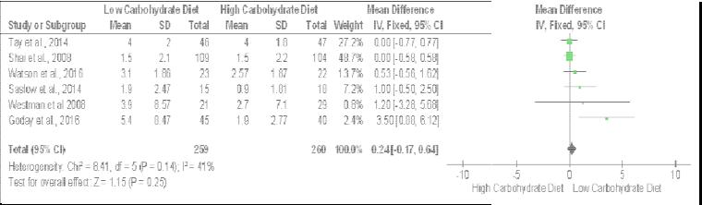

Figure 6 The effect of carbohydrate diet on BM I levels (/m2)
The initial two examinations recommended that high protein diets decline BMI however the last two investigations, which highlight a little range, actuated a mean contrast of 0. Along these lines, the mean distinction slanted towards high protein bites the dust ts diminishing BMI yet not contrasted with the low sugar result. The most concerning outcome are Westman et al., (2008) (Figure 7). Because of the Ellsworth et al., (201 6) having little p-esteem, the SD was expanded significantly and is in all likelihood an odd outcome. The reason the mean worth was very low notwithstanding the tremendous mean contrast revealed in Ellsworth et al., (2016), the gigantic certainty interim gives it low in general weight. The Mediterranean eating regimen has an insignificant impact on decreasing BMI levels (Figure 8).
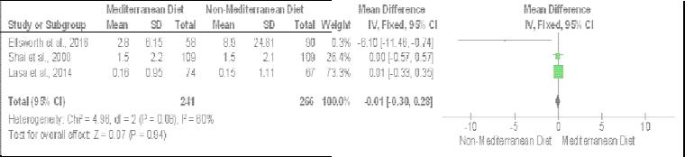

Figure 8 The effect of Mediterranean diet on BMI levels (/m2)
High-fat eating regimens were the best in diminishing BMI levels contrasted with all others. Lasa et al., (2014) detailed the biggest change in BMI for high-fat eating regimens contrasted with low-fat eating regimens which are the reason it was weighted higher contrasted with Shai et al., (2008) and Tay et al., (20 14) results. This is intrigued considering Tay et al., (2014) and Papakonstantinou et al., (2010) demonstrated no distinction in the impact of high and low-fat weight control plans on BMI (Figure 9) [25,26].

The Impact of eating routine on Abdomen Outline
The low-starch diet supports an abatement in abdomen estimate. Westman et al., (2008) detailed their outcomes midsection periphery in inches while the others were accounted for in centimeter (cm), so a choice was made to change over their outcomes to cm to support consistency (Figure 10).
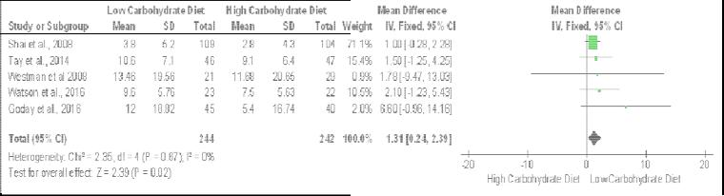

Figure 10 The effect of carbohydrate diet on waist circumference (cm)
The outcomes demonstrate no impact for protein content on mid-section circuit (Figure 11).
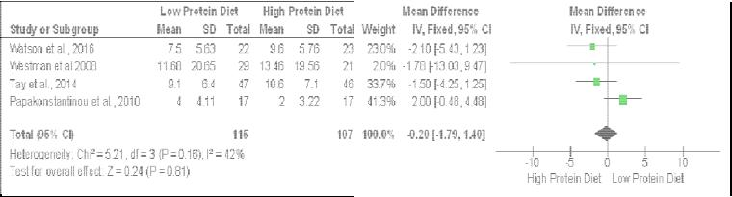

Figure 11 The effect of protein diet on waist circumference (cm)
The outcomes for Lasa et al., (2014) (Figure 12) were consolidated as results for guys and females were recorded independently. The outcomes demonstrate no impact for the Mediterranean eating regimens on midriff perimeter.
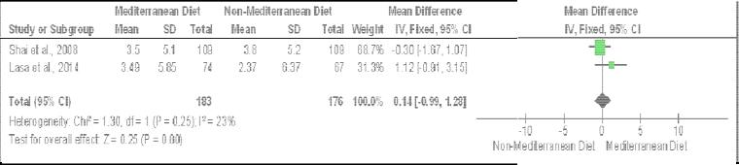

Figure 12 The effect of Mediterranean diet on waist circumference (cm)
The high-fat outcome showed the second-biggest decline in aftereffects of the examinations announced here. Anyway, the certainty interim for the consolidated outcome crosses the file.

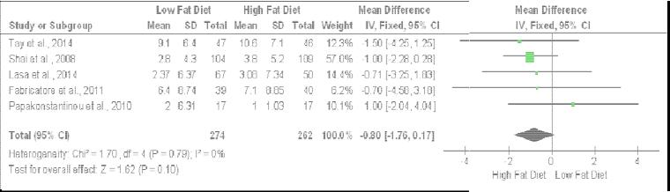

Figure 13 The effect of fat diet on waist circu mference (cm)

The impact of diet on LDL cholesterol
Westman et al., (2008) included a negative outcome since it spoke to the main outcome to display that a high-sugar diet expanded LDL level. The cholesterol results for Goday et al., (2016), Iqbal et al., (2009) and Shai et al., (2008) must be changed over from mg/dl to mmol/to keep the outcomes predictable. By and large, the high sugar diet shows up the best at lessening LDL cholesterol (Figure 14).
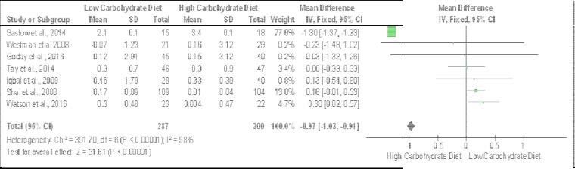

Figure 14 The effect carbohydrate diet on LDL ch olesterol (mmol/L)

The protein substance of the eating regimen demonstrated no critical impact on cholesterol levels (Figure 15).
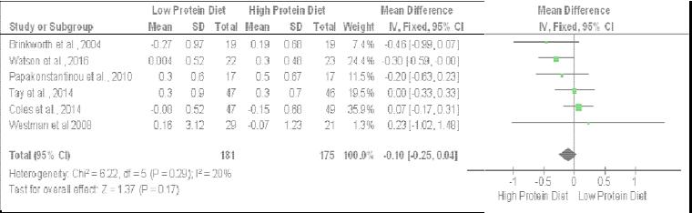

Figure 16 The effect of Mediterranean diets on LDL cholesterol (mmol/L)
The low-fat eating routine was compelling at decreasing LDL cholesterol contrasted with the high starch diet (Figure 17).

Fabricatore et al., (2011) and C oles et al., (2014) discovered low-fat eating regimens imperceptibly expanded L DL cholesterol levels, however the impacts noted in the other studie s were indisputable [18,27].
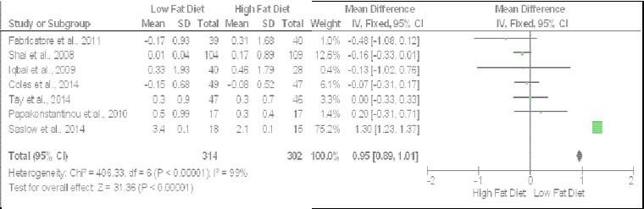

Figure 17 The effect of fat diets on LDL cholesterol (mmol/L)

The impact of weight control plans on HDL cholesterol
Low sugar diets were compelling in expanding HDL contrasted with high-starch diet (Figure 18). What emerges is three examinations cross the de cision line yet the general impact is clear. Saslow et al., (2014) and Westman et al., (2008) were avoided as they didn't have HDL levels.
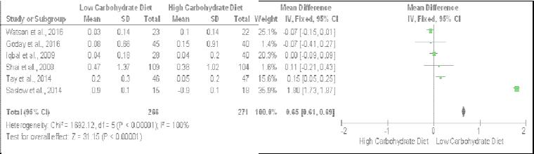

Figure 18 The effect of carbohydrate diet on HDL cholesterol (mmol/L)
Plainly the protein in the eating routine demonstrated no impact on cholesterol levels. (Figure19). Papakons tantinou et al., (2010) was excluded.
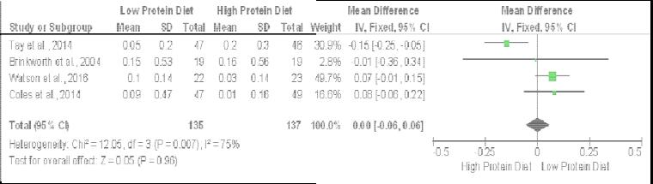

Figure 19 The effect of protein diets on HDL cholesterol (mmol/L)

Mediterranean eating regimens have a somewhat better impact on expanding HDL levels contrasted with non-Mediterranean weight control plans, however, it was not huge enough to be viewed as huge in light of the fact that it's hardly bigger (Figure 20).
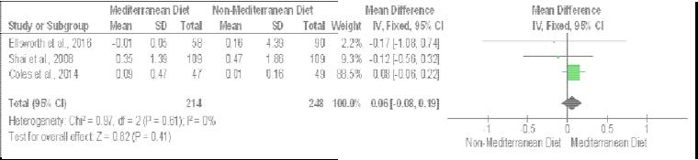

Figure 20 The effect of Mediterranean diet on HDL cholesterol levels (mm ol/L)

The authoritative end that can be made is that low-fat eating regimens are better in expanding HDL levels contrasted with high-fat weight control plans just as low-sugar levels (Figure 21). This is a bit of astonishing considering the initial four examinations recorded outcomes for the high-fat eating routine. Sas low et al., (2014) was incorporated into this examination. Papakonstantin ou et al. (2010) was excluded because of the high-fat eating routine having no impact on HDL decline yet there was a slight lessening see n in the lower fat eating regimen.

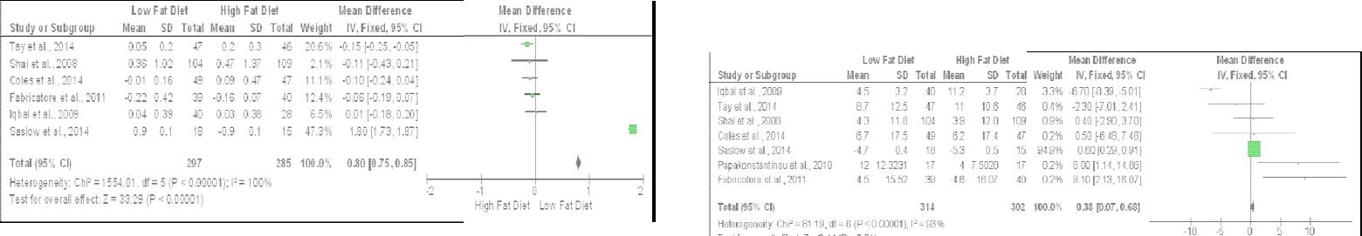

Figure 21 The effect of fat diet on HDL cholesterol (mmol/L) Figure 25 The effect of fat diet on systolic BP (mmHg)

The impact of weight control plans on systolic BP
Low-sugar diets included a superior abatement in BP contrasted with higher starch eats less (Figure 22). When taking a gander at the outcomes, the extents were comp aratively extraordinary for each investigation going from a 0.6 to 6.7 with the main examination supporting a diminishing in BP for high carbo hydrate diet being Shai et al., (2008).

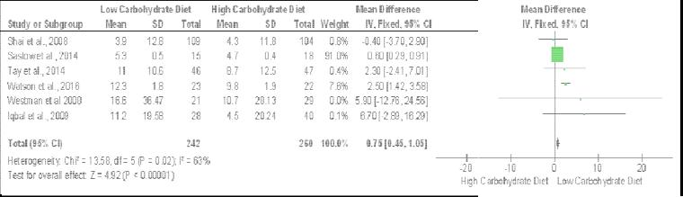

Figure 22 The effect of carbohydrate diet on systolic BP (mmHg)

The outcomes demonstrated that a higher protein diet causes a huge diminishing in systolic BP and this impact is large contrasted with the impact that a low-starch diet included on systolic BP (Figure 23). The reaches that were accounted for were considerably bigger contrasted with the ones that low-carbohydrate ones continued which extended from 0.5 to 8.30.
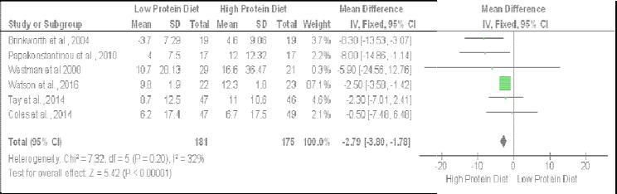

Figure 23 The effect of protein diet on systoli c BP (mmHg)

The Mediterranean eating regimen portrayed a superior decrease in systolic BP contrasted with the low-starch diet, albeit, just two investigations recorded the impacts of systolic BP for this. What doesn't help the outcomes epitomized when Coles et al., (2014) detailed non-Mediterranean eating regimen being better for diminishing BP and Shai et al., (2008) recording the inverse. The outcomes favored Shai et al., (200)8 on the grounds that Shai et al., 2008 included a bigger example size implying that its impact size will be superior to Coles et al., (2014) regardless of whether 96 members are as yet a sensible example estimate (Figure 24).

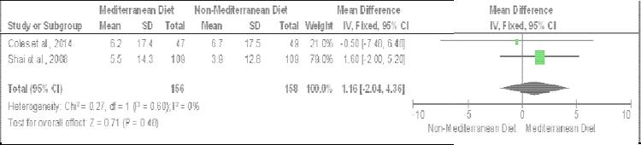

Figure 24 The effect of Mediterranean diet on systolic BP (mmHg)

At long last, low-fat eating regimens built up a superior decrease in systolic BP contrasted with higher-fat eating routine, yet this impact is littler contrasted with different weight control plans. The fascinating thing to note is the manner by which the two weight control plans have results with articulated impact with Iqbal et al., (2009) favoring the high-fat eating routine and Fabricatore et al., (2011) favoring the lower fat eating regimen (Figure 25)

Constraint
There are not many preliminaries that looked at the Mediterranean eating regimen, as needs are, the outcomes may have swung towards Mediterranean weight control plans having a superior advantage for those members as it was an eating routine most compared for large individuals as a rule.

5. Conclusion
The examinations that researched sugar eats less in contrast with others included a predictable outcome presuming that low-starch diets created a good decrease in heftiness and glucose levels [19,20,23,24,25,28]. The main investigation that couldn't help contradicting this end was Watson et al., (2016) who contended that high-starch diets were as viable as low-sugar slims down [29].

Shai et al., (2008) and Iqbal et al., (2009) reasoned that low-starches were better than low-fat eating regimens. Brinkworth et al., (2004) likewise explored the high and low-protein and fat eating routine, they inferred that fat substance had no impact at all [30]. The examinations that explored Mediterranean eating routine, Shai et al., (2008), Coles et al., (2004) and Lasa et al., (2004) all included more than 100 members in their preliminary giving more prominent unwavering quality in their discoveries contrasted with concentrates with less members. Shai et al., (2008) inferred that a low-starch and the Mediterranean eating regimen are better than low-fat weight control plans because of a progressively ideal impact on glycemic levels. Coles (2004) detailed that men favored being coordinated to their decision of eating routine (the non-Mediterranean eating routine) contrasted with females who favored having a decision (counting Mediterranean eating routine), (Coles et al., 2004). At long last, Lasa et al., (2014) presumed that Mediterranean eating regimens improved glucose digestion however to a similar degree as low-fat eating regimens. Also, entire grain consumes less calories, ketogenic diets, and veggie lover diets were incorporated into a portion of the examinations utilized in this survey. The entire grain diet considers by Malin et al., (2007) reasoned that the entire grain diet decreased the danger of achieving diabetes contrasted with refined-grain consumes less calories [31]. A low-calorie ketogenic diet was contrasted with a hypocaloric diet by Goday et al., (2016) which inferred that the exceptionally low ketogenic diet was increasingly viable [32]. Moreover, Gumbiner, Wendel, and McDermott (1996) examined high-ketogenic low-vitality slims down against low-ketogenic eats less carbs and finished up the previous prompted preferable glycemic impacts over the last [33]. At long last, Ellsworth et al., (2016) thought about an exacting veggie lover diet against a Mediterranean-style diet on insulin safe in T2DM and finished up both were similarly as viable. Protein diets have dependably been something that has been related with weight training so it was accepted there will be an advantage for all people including diabetic patients, in any case, this was not the situation. The high protein diet "diminishes hunger, improves satiety, increments thermogenesis" and while a higher protein admission does not build plasma glucose, it can "increment insulin reaction" which might be an issue for patients with T2DM in view of insulin opposition. Along these lines, if a high protein diet were to be suggested, the sum to be taken needs to in any event relate to an individual's body weight and not surpass that to counteract harm[34]. The third eating regimen that affected corpulence was the low-fat eating routine, however this outcome was scarcely progressively powerful when contrasted with the high-fat eating regimen. When discussing fat, it's imperative to recall that the reality examined is trans-fat as they increment LDL levels, decline HDL levels and increment the proportion of triglycerides to HDL cholesterol just as expanding triglycerides. Generally, these add to an expanded danger of cardiovascular infection from happening because of atherosclerosis [35]. Notwithstanding, there additionally exist unsaturated fats that continue dimensions of HDL cholesterol while diminishing LDL cholesterol [36]. "Unsaturated fats impact glucose digestion by changing cell layer work, compound action, insulin flagging, and quality articulation". Because of this, the proof has reliably recommended that "supplanting immersed fats and trans unsaturated fats with unsaturated fats effectsly affect insulin affectability and are probably going to decrease the danger of sort 2 diabetes" [37]. At last, the eating regimen that accomplished the least effect was the Mediterranean weight control plans, despite the fact that, the Mediterranean eating regimen was practically identical to the high-fat eating routine. While Mediterranean eating regimen did not have a critical effect on stoutness in patients determined to have diabetes, there is proof that proposes they're valuable for corpulent patients with diabetes, the impact isn't as noteworthy contrasted with the remainder of the eating regimens and could be recommended as an option.

Taking everything into account, the precise survey distinguished the low sugar (not low enough to incite ketosis), high protein diet and high unsaturated fat eating regimen, in a specific order, is the most ideal decisions. By and large, there are huge quantities of eating regimens professing to be better than others yet in addition tending to various angles, for example, solid living, weight the executives, cardiovascular advantage, strong appearance advantage, vitality advantage, and the rundown goes for extremely long. Despite an eating regimen type, adjusted sustenance that can be pursued long haul and produce medical advantage results is the best eating regimen for patients with an unending condition.

6. References
[1] UN.org. (2018). United Nations Millennium Development Goals. [online] Available at: http://www.un.org/millenniumgoals/poverty.shtml [Accessed 27 Aug. 2018].

[2] Boseley, S. and Davidson, H. (2015). Global obesity rise puts UN goals on diet-related diseases 'beyond reach'. [online] the Guardian. Available at: https://www.theguardian.com/society/2015/oct/09/obesi tys-global-spread-un-goals-diet-related-diseases-fail [Accessed 27 Aug. 2018].

[3] Alison, M. (2016). Health Survey for England 2015 Adult overweight and obesity. London: Natcen Social Research.

[4] United Nations Sustainable Development. (2015). Sustainable development goals - United Nations. [online] Available at: https://www.un.org/sustainabledevelopment/sustainable -development-goals/. [Accessed 27 Aug. 2018].

[5] Mcleod, S. (2018). Maslow's Hierarchy of Needs. [online] Simply Psychology. Available at: https://www.simplypsychology.org/maslow.html [Accessed 20 Nov. 2018].

[6] Dublin, L. and Lotka, A. (1938). Twenty-Five Years of Health Progress: A Study of the Mortality Experience Among the Industrial Policyholders of the Metropolitan Life Insurance Company 1911 to 1935. Journal of the American Medical Association, 110(4).

[7] Haslam, D. (2007). Obesity: a medical history. Obesity Reviews, 8(s1), pp.31-36.
[8] Guh, D., Zhang, W., Bansback, N., Amarsi, Z., Birmingham, C. and Anis, A. (2009). The incidence of co-morbidities related to obesity and overweight: A systematic review and meta-analysis. BMC Public Health, 9(1).

[9] De Pergola, G. and Silvestris, F. (2013). Obesity as a Major Risk Factor for Cancer. Journal of Obesity, 2013, pp.1-11.

[10] Gatineau M, Dent M. Obesity and Mental Health. Oxford: National Obesity Observatory, 2011

[11] Alzheimer's Society. (2018). Investigating the relationship between mid-life obesity and changes in the brain leading to Alzheimer's disease later in life. [online] Available at: https://www.alzheimers.org.uk/research/our- research/research-projects/relationship-mid-life-obesity- alzheimers-disease [Accessed 10 Sep. 2018].

[12] Al-Goblan, A., Al-Alfi, M. and Khan, M. (2014). Mechanism linking diabetes mellitus and obesity. Diabetes, Metabolic Syndrome and Obesity; Targets and Therapy, (7), pp.587-591.

[13] GOV.UK. (2017). Health matters: obesity and the food environment. [online] Available at: https://www.gov.uk/government/publications/health- matters-obesity-and-the-food-environment/health- matters-obesity-and-the-food-environment--2 [Accessed 16 Sep. 2018].

[14] Diabetes.co.uk. (2018). Diabetes and Obesity. [online] Available at: https://www.diabetes.co.uk/diabetes-and- obesity.html [Accessed 10 Sep. 2018].

[15] Donnelly, L. and Newey, S. (2018). UK bottom of league table for life expectancy gains. [online] The Telegraph. Available at: https://www.telegraph.co.uk/news/2018/08/07/uk- bottom-league-table-life-expectancy-gains/ [Accessed 10 Dec. 2018].

[16] Gatineau M, Hancock C, Holman N, Outhwaite H, Oldridge L, Christie A, Ells L. Adult obesity and type 2 diabetes. Oxford: Public Health England, 2014.

[17] Ellsworth, D., Costantino, N., Blackburn, H., Engler, R., Kashani, M. and Vernalis, M. (2016). Lifestyle modification interventions differing in intensity and dietary stringency improve insulin resistance through changes in lipoprotein profiles. Obesity Science & Practice, 2(3), pp.282-292.

[18] Coles, L., Fletcher, E., Galbraith, C. and Clifton, P. (2014). Patient freedom to choose a weight loss diet in the treatment of overweight and obesity: a randomized dietary intervention in type 2 diabetes and pre-diabetes. International Journal of Behavioral Nutrition and Physical Activity, 11(1), p.64.

[19] Iqbal, N., Vetter, M., Moore, R., Chittams, J., Dalton- Bakes, C., Dowd, M., Williams-Smith, C., Cardillo, S. and Wadden, T. (2009). Effects of a Low-intensity Intervention That Prescribed a Low-carbohydrate vs. a Low-fat Diet in Obese, Diabetic Participants. Obesity, 18(9), pp.1733-1738.

[20] Shai, I., Schwarzfuchs, D., Henkin, Y., Shahar, D., Witkow, S., Greenberg, I., Golan, R., Fraser, D., Bolotin, A., Vardi, H., Tangi-Rozental, O., Zuk-Ramot, R., Sarusi, B., Brickner, D., Schwartz, Z., Sheiner, E., Marko, R., Katorza, E., Thiery, J., Fiedler, G., Blüher, M., Stumvoll, M. and Stampfer, M. (2008). Weight Loss with a Low-Carbohydrate, Mediterranean, or Low- Fat Diet. New England Journal of Medicine, 359(3), pp.229-241.

[21] Lasa, A., Miranda, J., Bulló, M., Casas, R., Salas- Salvadó, J., Larretxi, I., Estruch, R., Ruiz-Gutiérrez, V. and Portillo, M. (2014). Comparative effect of two Mediterranean diets versus a low-fat diet on glycaemic control in individuals with type 2 diabetes. European Journal of Clinical Nutrition, 68(7), pp.767-772.

[22] Klop, B., Elte, J. and Cabezas, M. (2013). Dyslipidemia in Obesity: Mechanisms and Potential Targets. Nutrients, 5(4), pp.1218-1240.

[23] Saslow, L., Kim, S., Daubenmier, J., Moskowitz, J., Phinney, S., Goldman, V., Murphy, E., Cox, R., Moran, P. and Hecht, F. (2014). A Randomized Pilot Trial of a Moderate Carbohydrate Diet Compared to a Very Low Carbohydrate Diet in Overweight or Obese Individuals with Type 2 Diabetes Mellitus or Prediabetes.

[24] Westman, E., Yancy, W., Mavropoulos, J., Marquart, M. and McDuffie, J. (2008). The effect of a low- carbohydrate, ketogenic diet versus a low-glycemic index diet on glycemic control in type 2 diabetes mellitus. Nutrition & Metabolism, 5(1), p.36.

[25] Tay, J., Luscombe-Marsh, N., Thompson, C., Noakes, M., Buckley, J., Wittert, G., Yancy, W. and Brinkworth, G. (2014). A Very Low-Carbohydrate, Low–Saturated Fat Diet for Type 2 Diabetes Management: A Randomized Trial. Diabetes Care, 37(11), pp.2909- 2918.

[26] Papakonstantinou, E., Triantafillidou, D., Panagiotakos, D., Koutsovasilis, A., Saliaris, M., Manolis, A., Melidonis, A. and Zampelas, A. (2010). A high-protein low-fat diet is more effective in improving blood pressure and triglycerides in calorie-restricted obese individuals with newly diagnosed type 2 diabetes. European Journal of Clinical Nutrition, 64(6), pp.595- 602.

[27] Fabricatore, A., Wadden, T., Ebbeling, C., Thomas, J., Stallings, V., Schwartz, S. and Ludwig, D. (2011). Targeting dietary fat or glycemic load in the treatment of obesity and type 2 diabetes: A randomized controlled trial. Diabetes Research and Clinical Practice, 92(1), pp.37-45.

[28] Miyashita, Y., Koide, N., Ohtsuka, M., Ozaki, H., Itoh, Y., Oyama, T., Uetake, T., Ariga, K. and Shirai, K. (2004). Beneficial effect of low carbohydrate in low calorie diets on visceral fat reduction in type 2 diabetic patients with obesity. Diabetes Research and Clinical Practice, 65(3), pp.235-241.

[29] Watson, N., Dyer, K., Buckley, J., Brinkworth, G., Coates, A., Parfitt, G., Howe, P., Noakes, M. and Murphy, K. (2018). Effects of Low-Fat Diets Differing in Protein and Carbohydrate Content on Cardiometabolic Risk Factors during Weight Loss and Weight Maintenance in Obese Adults with Type 2 Diabetes.

[30] Brinkworth, G., Noakes, M., Parker, B., Foster, P. and Clifton, P. (2004). Long-term effects of advice to consume a high-protein, low-fat diet, rather than a conventional weight-loss diet, in obese adults with Type 2 diabetes: one-year follow-up of a randomised trial. Diabetologia, 47(10), pp.1677-1686.

[31] Malin, S., Kullman, E., Scelsi, A., Haus, J., Filion, J., Pagadala, M., Godin, J., Kochhar, S., Ross, A. and Kirwan, J. (2017). A whole-grain diet reduces peripheral insulin resistance and improves glucose kinetics in obese adults: A randomized-controlled trial. Metabolism, 82, pp.111-117.

[32] Goday, A., Bellido, D., Sajoux, I., Crujeiras, A., Burguera, B., García-Luna, P., Oleaga, A., Moreno, B. and Casanueva, F. (2016). Short-term safety, tolerability and efficacy of a very low-calorie-ketogenic diet interventional weight loss program versus hypocaloric diet in patients with type 2 diabetes mellitus.

[33] Gumbiner, B., Wendel, J. and McDermott, M. (1996). Effects of diet composition and ketosis on glycemia during very-low-energy-diet therapy in obese patients with non-insulin-dependent diabetes mellitus. The American Journal of Clinical Nutrition, 63(1), pp.110- 115

[34] Hamdy, O. and Horton, E. (2011). Protein Content in Diabetes Nutrition Plan. Current Diabetes Reports, 11(2), pp.111-119.

[35] Whittlesea, C. and Hodges, K. (2018). Clinical Pharmacy and Therapeutics. 6th ed. [S.l.]: Churchill Livingstone, p.427.

[36] nhs.uk. (2017). Fat: the facts. [online] Available at: https://www.nhs.uk/live-well/eat-well/different-fats- nutrition/ [Accessed 14 Feb. 2019].

[37] Riserus, U., Willett, W. and Hu, F. (2009). Dietary fats and prevention of type 2 diabetes. Progress in Lipid Research, 48(1), pp.44-51.

